- Switch & Router Configuration

Q.1 Log in to Cisco Packet Tracer or any network simulation tool, add a switch, and create two VLANs named 'Sales' and 'Support' with VLAN IDs 10 and 20?

Answer

- I created two VLANs on a Cisco 2960 switch in Packet Tracer.
- VLAN 10: Sales
- VLAN 20: Support
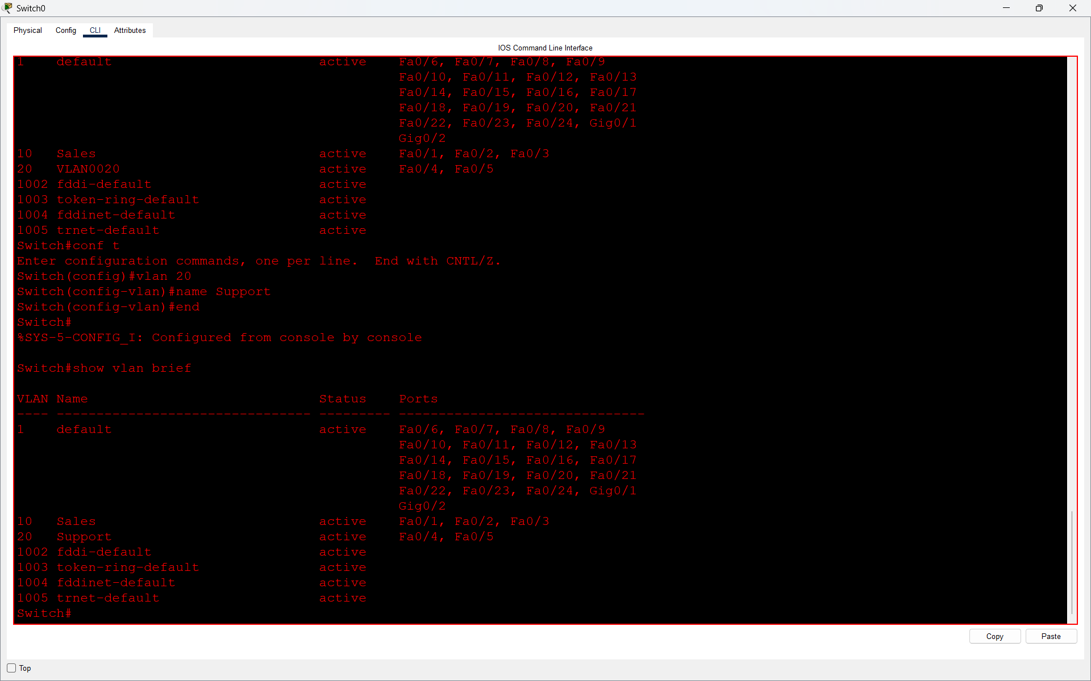
- Result:
Both VLANs were created successfully on the switch.

Q.2 Assign three different switch ports to VLAN 10 (Sales) and two ports to VLAN 20 (Support), then verify the VLAN membership using the show vlan command.<br><br><em><strong>Hint:</strong> Use the interface range command to select multiple ports efficiently.</em>?

Answer

- I assigned three switch ports to VLAN 10 and two switch ports to VLAN 20.
- VLAN 10 – Sales: Fa0/1, Fa0/2, Fa0/3
- VLAN 20 – Support: Fa0/4, Fa0/5

I used the show vlan brief command to verify the VLAN membership.

- Result:
The command confirmed that the ports were assigned to the correct VLANs.

Q.3 Connect two routers using a serial or Ethernet link in your simulation tool, assign IP addresses to their interfaces, and configure a static route on Router 1 to reach the LAN behind Router 2?

Answer

- Static Routing Between Two Routers
I connected two routers using an Ethernet link and configured IP addresses on their interfaces.
- Router 0
- G0/0: 10.0.0.1/30
- G0/1: 192.168.1.1/24
- Router 1
- G0/0: 10.0.0.2/30
- G0/1: 192.168.2.1/24
- I configured a static route on Router 0 to reach the network behind Router 1:
ip route 192.168.2.0 255.255.255.0 10.0.0.2
- I also configured the return route on Router 1:
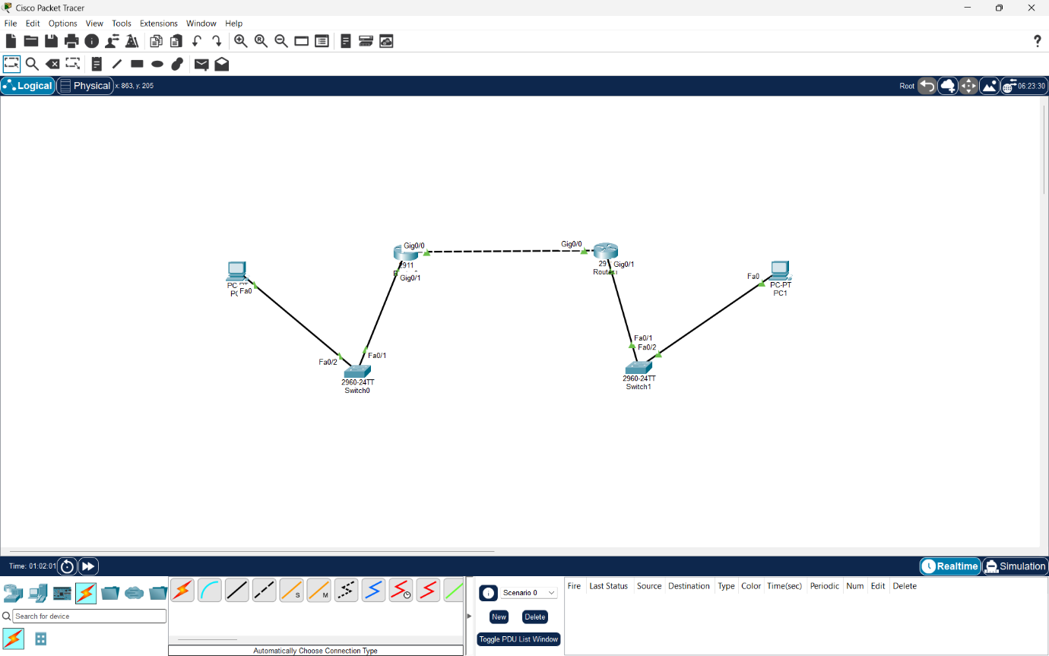
ip route 192.168.1.0 255.255.255.0 10.0.0.1
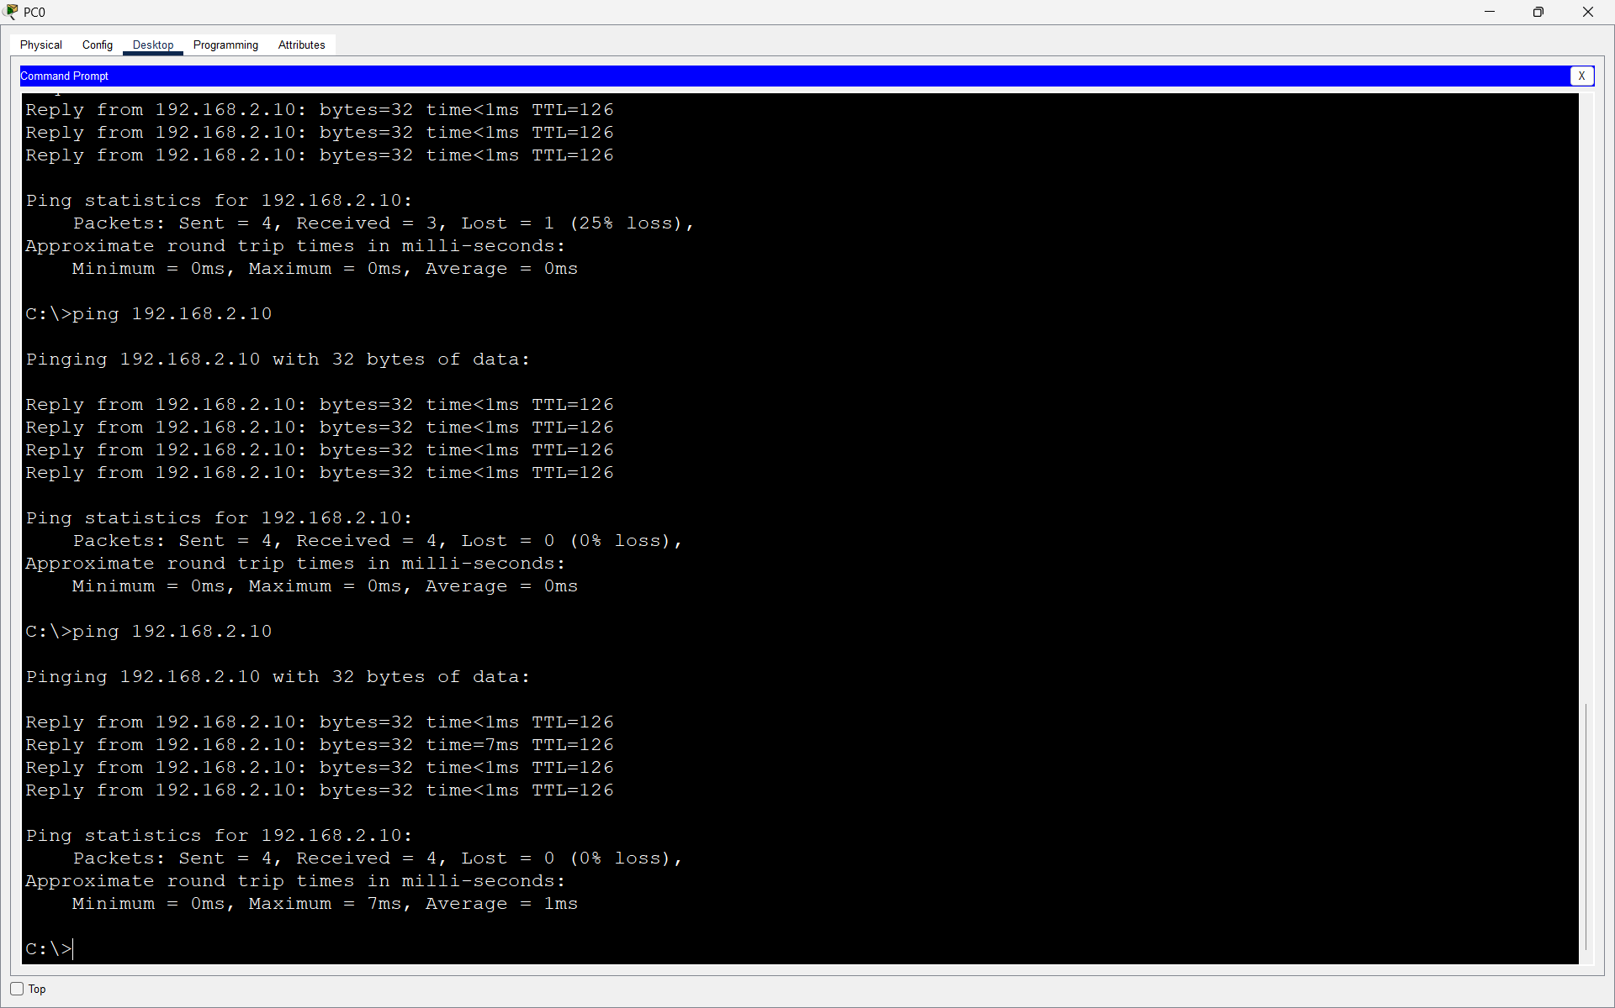
- Result:
The routers and PCs communicated successfully. PC0 was able to reach the device on the 192.168.2.0/24 network, confirming that the static routing configuration was working correctly.

Q.4 Simulate a scenario where a device in the 'Sales' VLAN tries to ping a device in the 'Support' VLAN and explain why the ping fails, then suggest what configuration would allow inter-VLAN communication.<br><br><em><strong>Hint:</strong> Think about router-on-a-stick or Layer 3 switch concepts.</em>?

Answer

- Communication Between Sales and Support VLANs
I configured PC0 in VLAN 10 (Sales) and PC1 in VLAN 20 (Support).
- Sales PC IP: 192.168.10.10
- Support PC IP: 192.168.20.10
This shows the VLAN membership on the switch.
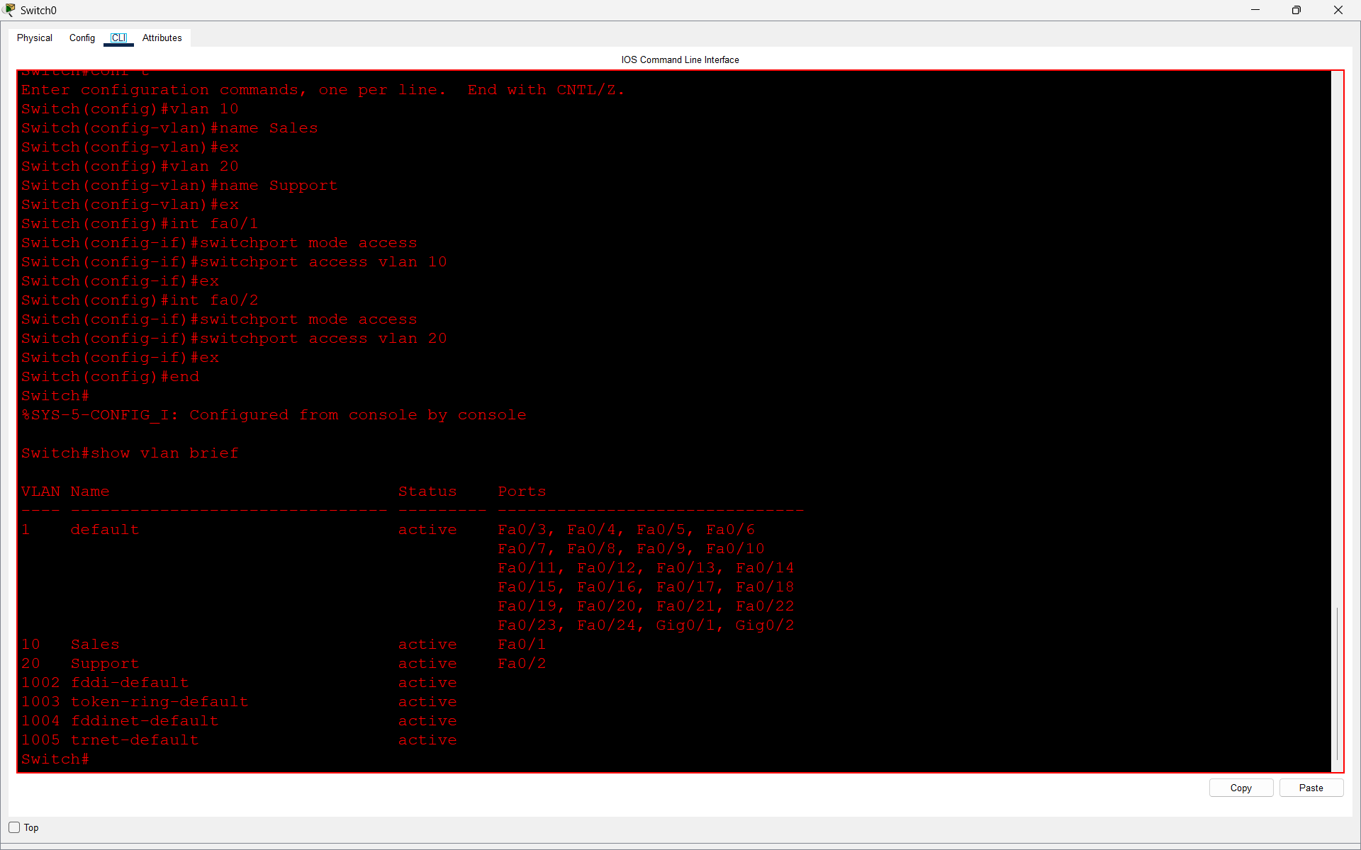
- Then I tested communication from the Sales PC to the Support PC using:
ping 192.168.20.10
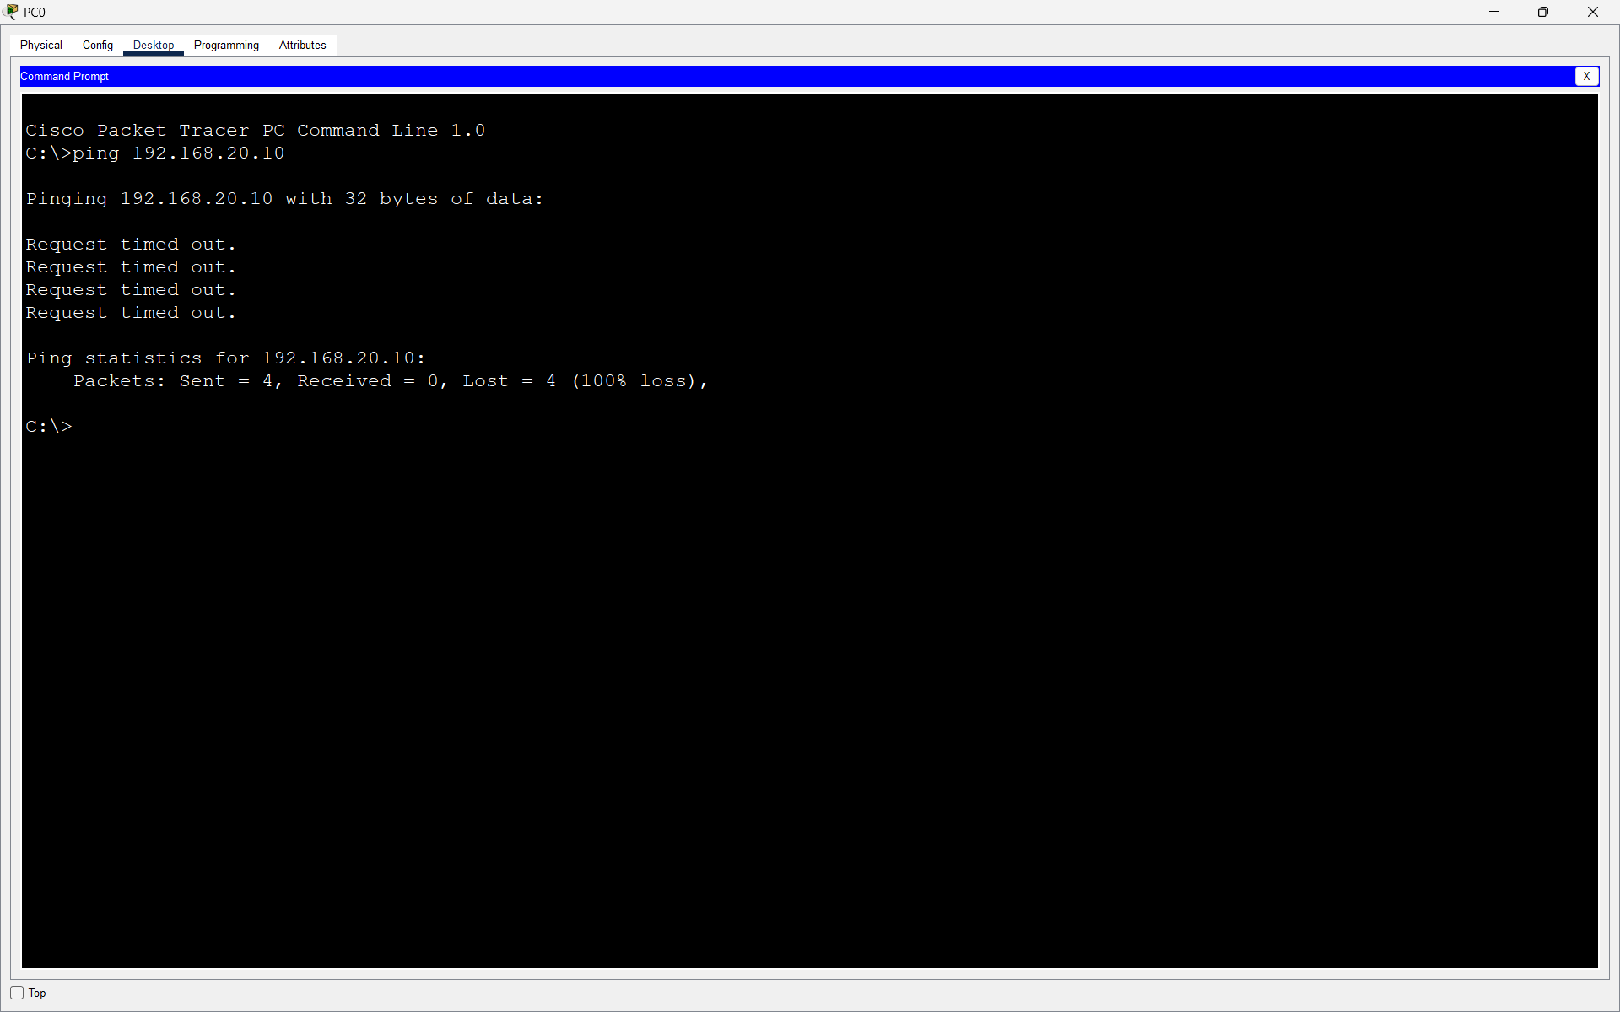
- Result:
The ping failed with 100% packet loss because VLAN 10 and VLAN 20 are separate logical networks. A Layer 2 switch cannot route traffic between different VLANs.

